UML – Unified Modeling Language

- UMLet plugin in eclipse to create UML Diagram.
- Class Diagram

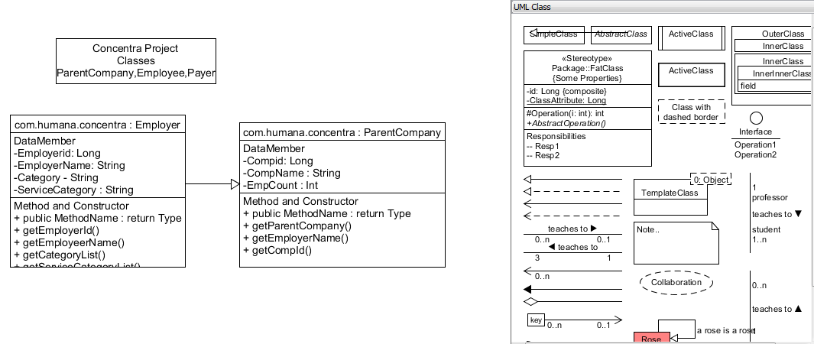
Notation Used :
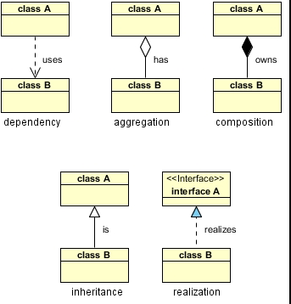
The above relationships are read as follows:
- Dependency : class A uses class B
- Aggregation : class A has a class B
- Composition : class A owns a class B
- Inheritance : class B is a Class A (or class A is extended by class B)
- Realization : class B realizes Class A (or class A is realized by class B)

- Association : Class A holds reference to Class B.
- Aggregation : a Professor 'has a' class to teach
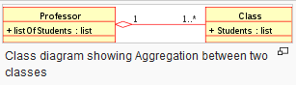
- Composition and Aggregation are both are similar but with some difference .
Composition relationship : engine is a part of a car.
Aggregation relationship : car model engine ENG01 is part of a car model CM01, as the engine, ENG01 may be also part of a different car model.
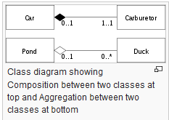
Generalization : Sub classes depends on the super class . Generalization is a hollow triangle shape on the superclass end of the line
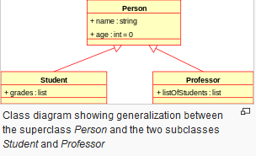

Sequence Diagram
- most common kind of interaction diagram, which focuses on the message interchange between a number of lifelines
- Create and Delete message, synch and Async call , lifeline etc..
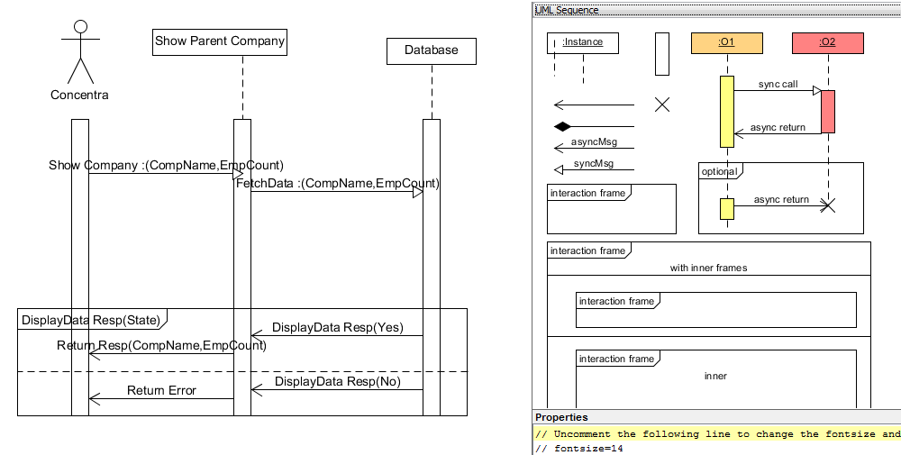

Use Case Diagram
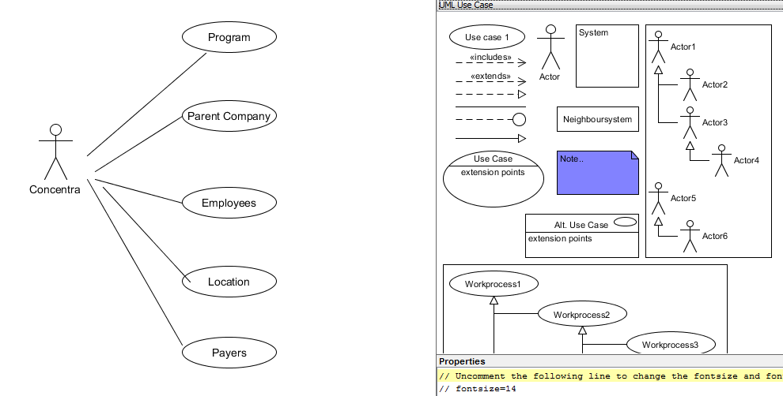
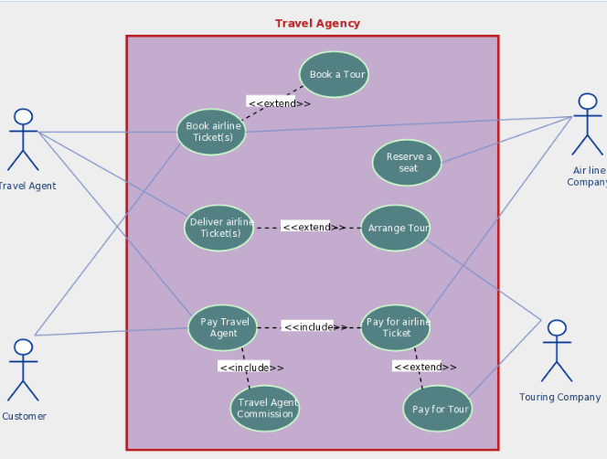

Notation like
  - Assosiation , Include and Extend. Circle is( use case)

